**Course: Advance Bio Informatics**

**Module Title: Security Actions for Biological Data**

**Module No: 157**

**What is e-Health?**

Internet-enabled Healthcare Applications – Consumer Health Information – Personal Health Records – Internet-based Services (e-Pharmacy, e-Care (incl. email and e-communication, etc.)

• Electronic Health Record (EHR) Systems

• Administrative and Financial Health Systems

How is Healthcare Security Different from Other Industries?

• Not bilateral conditions

• Regulated (US: HIPAA and other regulations)

• Community interest

• Legal issues

**e-Health Security Issues**

• Security for (Patient) Confidentiality

• Security that Enables Electronic Health Records

– Authentication

– Data Integrity

• Systems Security

– Secure Transmission

– Secure Processing

– Secure Storage

– Etc.

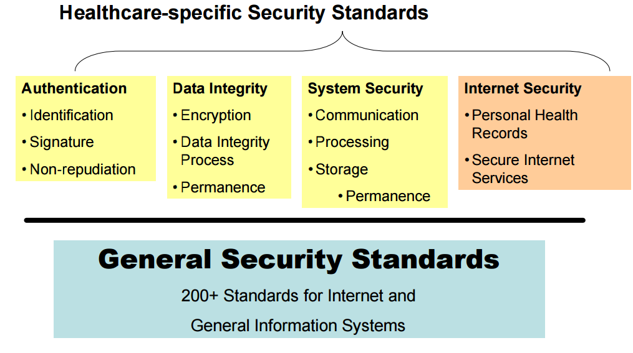

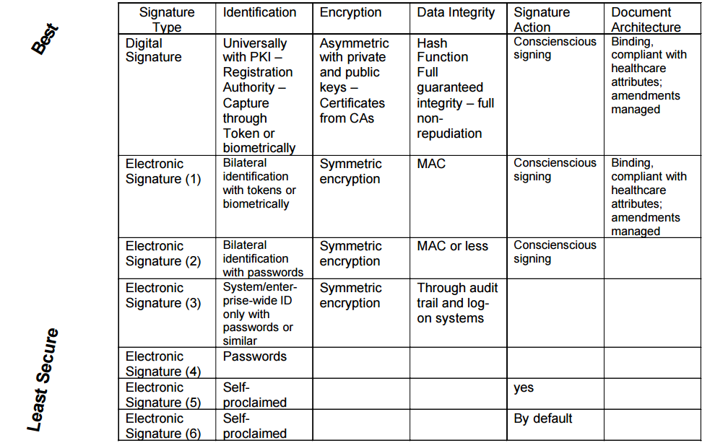

Security on Internet

* Reliability of Health Information on internet
* Trust to e-care
* Trust to e-pharmacy

**Guidelines for Security**

* Focus on reducing corporate and personal risks
* Use strong passwords
* Use Antivirus software
* Use Encryption
* Don’t use Wi-Fi in a public place to access a website containing personal information
* Educate staff and family
* Don’t open unsolicited attachments

Security Action

* User should lock screens when not at desk
* Report strange activity to network administration

**Enforce Accountability**

HIPPA regulations punish individuals or organizations that fail to keep PHI confidential. Criminal penalties for knowingly violating the HIPAA rules may include monetary fine as well as imprisonment.

In general, the use of data security protections is fairly high for:

Access control methods

Protection of data over networks

Protection of data within the enterprise

The area where data security protection is least implemented is authentication of users. IHDSOs have significantly higher levels of implementation; Hospitals are slightly above average. Medium/Large practices are about average; and Solo/Small practices fall significantly below average. IHDSOs are especially strong in implementing data security protection within the enterprise (i.e., policies and practices, backup/recovery procedures, and Audit logs). In contrast, Solo/Small practices are weakest in implementing data security protection within the enterprise